President Pranab Mukherjee with Olympics Medal Winners
Saina Nehwal and Others during a felicitation function
at Rashtrapati Bhavan.

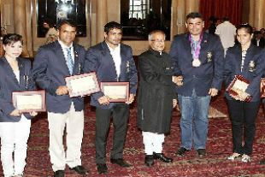

August 18, 2012, New Delhi : Calling for creating a strong sporting Nation with sound sports infrastructure, President Pranab Mukherjee today set the ball rolling for the next Olympics in Brazil expressing hope that India will improve its ranking in the world. The President said, "there is no time to rest on laurels. We must collectively lift our nation to greater heights. The onus for doing so is not just on our Athletes and Sports Authorities. It must become the duty of every citizen to promote a sporting culture in our country,"

He also asked major Corporates to sponsor, help identify and nurture talent.
"A strong sporting nation can be built only on the foundation of sound sports infrastructure. We must create sports facilities across the country and nurture talent from the grassroots, "the President said.
"Let preparations for the next Olympics begin from today itself. Let us set our goals high and tell ourselves - 'Rio, Here We Come'.

